# INTER CLUB YOUTH EXCHANGE PROGRAMME(7th february, 2020)

Rotaract Club of Waknaghat organised a heartwarming welcome session for rotaractors from Dombivli Suncity ,Rotaract District 3142. The fellow rotaractors were facilitated with a Himachali topi and hand-made newspaper cycles. Diversity and customs are two very beautiful prospects that define a human, a beautiful painting depicting cultural exchange was gifted to them. To add more charm, Rtr. Soham expressed his feelings through a beautiful poem. It was followed by an interactive session where everyone shared their treasure of experiences and thoughts. Rotaractors from Dombivli were overwhelmed to see such immense bonding and dedication of RACW. All in all, it was an indelible meet-up.

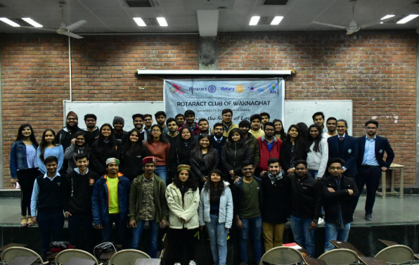

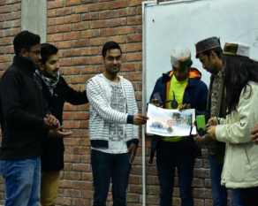 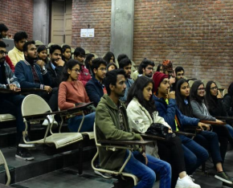

**JASHAN (8th february 2020 – 9th february 2020)**

“Life is to be enjoyed, not just endured. Live and work but do not forget to play, to have fun in life and really enjoy it. When fun gets deep enough, it can heal the world.” With this high spirit, Rotaract club of Waknaghat organized a two-days fun event- “JASHAN ” to break the monotonous routine of members and other students. The event included games like 7 up 7 down, the crazy joker, dare to bonk, the cup game, the coin drop. Rotaractors were successful in attracting large crowd of enthusiastic students. It was riveting to see excitement among those who won and a little dejection among those who lost. Prizes were awarded to those who won. The spree of games led to stronger networking and establishing a congenial atmosphere among the club members. It was a great way to facilitate bonding with Rotaractors, reduce academic stress, and give them the chance to get to know one another outside the club too. Altogether, with due efforts of everyone, the event concluded on triumphant note.

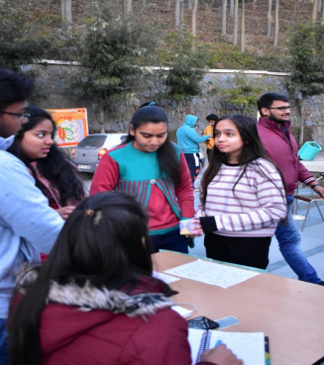 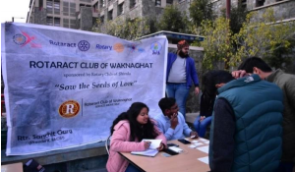

**STINKY FISH(27-february-2020)**

“To be happy means to be happy not only from pain but from fear and anxiety too.” Concerning this matter Rotaract club of Waknaghat organized an event "Stinky Fish" so that the fellow Rotaractors can express their weaknesses and fears by writing it down on a piece of paper. The stinky fish is a metaphor for "that thing that you carry around but don’t like to talk about; but the longer you hide it, the stinker it gets." By putting stinky fish (fears and anxieties) on the table, members began to relate to each other, became more comfortable sharing, and identified a clear area for development and learning. “When we get down to our fears, we find a way to conquer them.” The motive of creating openness in the club was achieved and a congenial atmosphere was created. Everyone is looking forward to convert their weaknesses into strengths and polish their personalities.

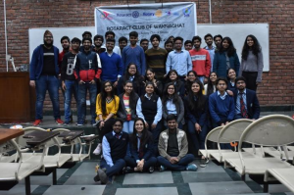 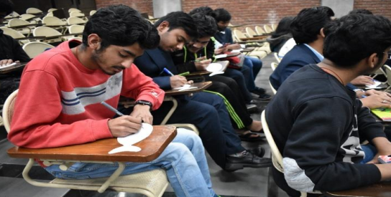

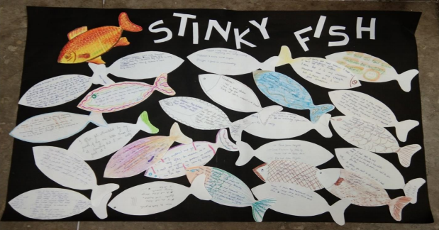

**FLAMBOYANCE BASH(25th February, 2020)**

Just like every month this month too, the rotaractors celebrated the birthdays of their club members for the month of November. In a small informal club gathering, everyone joined and wished the Rotaractors a very Happy Birthday, along with a huge birthday cake and refreshments for everyone.

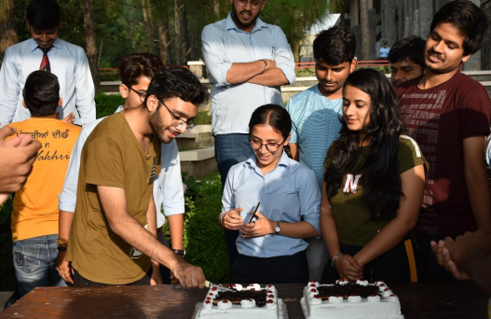

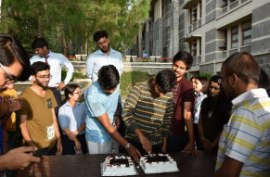

**Visit to an Orphanage(4th March, 2020)**

As we lose ourselves in the service of others, we discover our own lives and our happiness. The members of Rotaract Club of Waknaghat organized “Visit to an orphanage". Keeping the spirit of , ‘Service above self’, alive members volunteered to interact with disabled and mentally challenged children and distributed sweets and stationary to them. Children were ecstatic to have food from outside and even more elated when they received the stationary. Everyone separated themselves and went individually to talk to everyone. Many started playing indoor games with the children while many chose to play outdoor games. The team spent a little over two hours with the children before saying goodbye to them. It was indeed a fulfilling experience for the members as they could bring smiles on children’s faces.

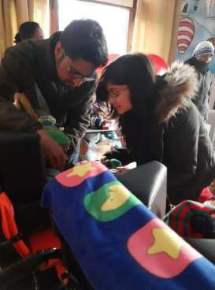 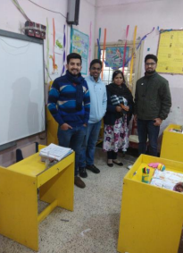

**Colour Click(9 th March 2020 – 11th March 2020)**

“Photography is the only language that can be understood anywhere in the world.” To the celebrate bright colours, water balloons, lavish gujiyas and melodious songs, Rotaract Club of Waknaghat organised, ‘COLOUR CLICKS.’ All the members were required to send photographs of their celebration of this colourful festival. Ardent participants sent their best clicks and made the most of this opportunity. All the photographs were featured on our social media platforms to encourage and appreciate the efforts of the contestants. The best photograph award was given to Rtr. Yash Aggarwal for his wonderstruck photograph.

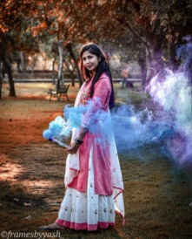 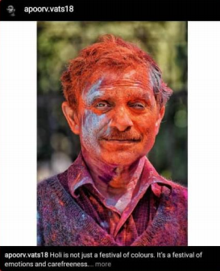

**Jaadu – e – Alfaaz (08-March-2020)**

The occasion of International Women’s Day was celebrated on 8th March 2020. The Rotaract Club of Waknaghat decided to take an initiative to make this day memorable and organized a creative writing competition “Jaadu – e – Alfaaz” which was open for everyone to be a part of it. All the participants had to do was write about the most special women in their life and where language was no barrier. After the write-up was prepared they had to post it on their Instagram page along with the photograph of that person and had to tag @rotaractwakna3080. These poets were to be judged based on how creative and unique the write-ups were. The best Write-up award was given to Rtr. Angima Anthwal for her creativity.

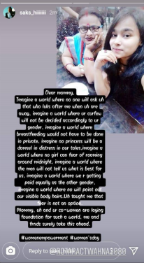 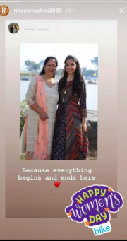

**Monthly Theme Project: Queerific(31-March-2020)**

“Never be bullied into silence. Never allow yourself to be made a victim. Accept no one’s definition in your life; define yourself.” Rotaract Club Of Waknaghat organized,’ Queerific’, an online meeting with a marvelous, warm-hearted personality, ‘Mr.Harrish Iyer’. He is an Equal Rights Activist, Gender and Sexuality Educator, Columnist and Blogger. His dynamic footsteps have embraced prestigious platforms like, Satyamev Jayate, TEDtalk, Josh Talk, to name a few. The meeting started at 6pm on the Zoom cloud application. All the members were extremely enthusiastic to have a platform to interact with a man of such a magnetic persona with dynamic achievements.

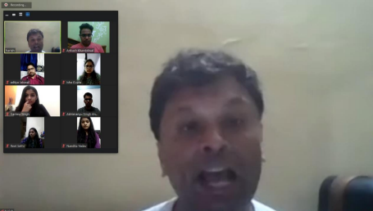

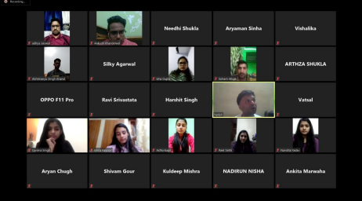

**Sister Club Project : Debate on Wildlife(21-March-2020)**

Rotaract Club of Dombivli Suncity did this debate with Rotaract Club of Waknaghat 3080.This debate consisted of members from both the clubs, spreading awareness amongst each other on the topic of forests, nature, wildlife, etc. Got to know each other’s opinions & viewed over the same thing from different perspectives. As this debate was taken up through "Skype" several members from each club participated & shared their views, opinions towards the wildlife & nature. This was a much needed debate more over a discussion on environment. Both the clubs agreed & initiated this project. Several important topics were covered up.

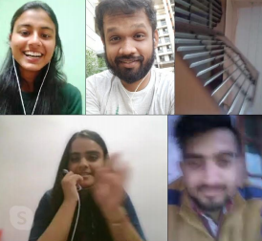 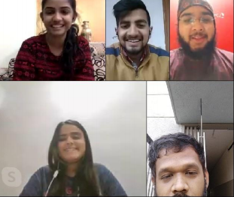

**Reversing the quarantine(30th March-4th April 2020.)**

"Insulated from all the plastic glitter mankind becomes mentally fitter”,

With this high spirit, Rotaract club of Waknaghat organized, “Reversing the quarantine”. All the participants were supposed to share their innovative ways of killing boredom during the quarantine period. It turned out to be a trending event, which fetched lots of participation. Ranging from deliciously cooked meals to tantalizing art, a lot of people participated in this event enthusiastically. All in all, it was a tremendous success.

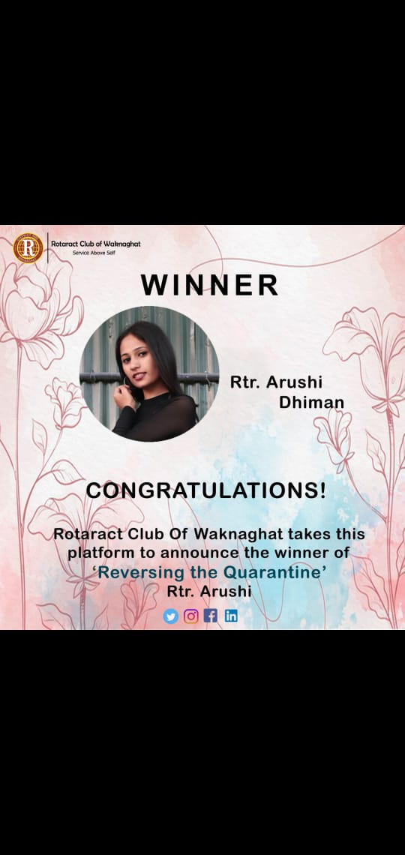 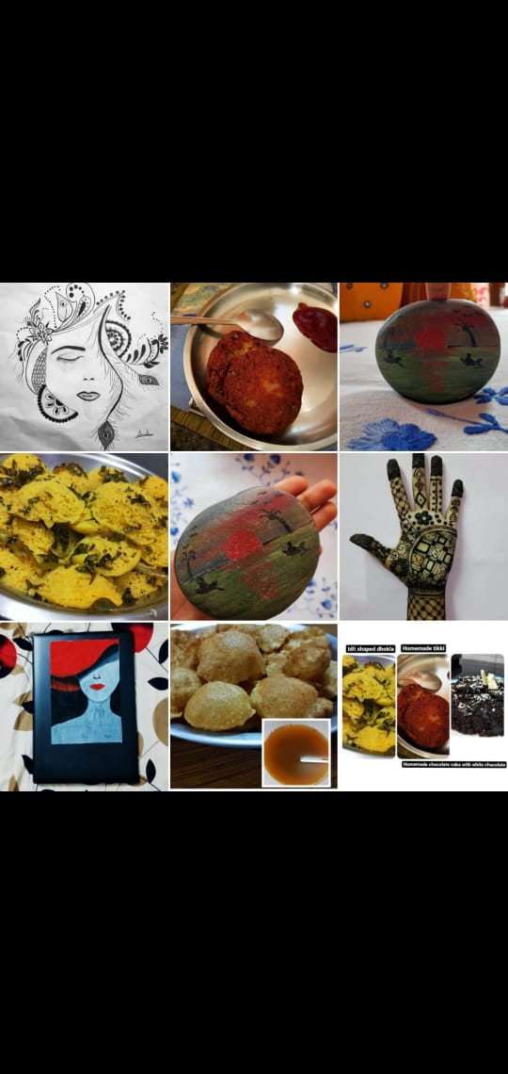

**Sanitizers distribution(8th April 2020)**

Amid Covid-19 crisis, the underprivileged section of our society was getting affected the most. They didn’t have access to basic necessities.

So, Rotaract Club of Waknaghat took it upon themselves to help the needy ones by distributing sanitizers to them.

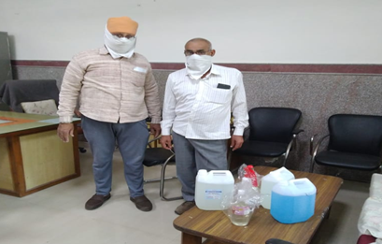

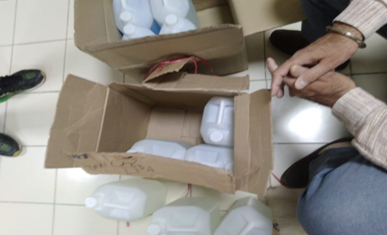

**DRR Visit(14-April-2020)**

The DRR visit was conducted through an online video conferencing attended by all the club members. A brief narrative of various events of the tenure was presented via presentation and the Rotaractors were motivated for future endeavors.

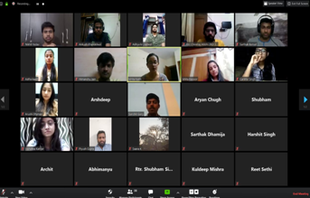

**Feed the Pawsome(17 April 2020)**

Rotaract club of Wakhnaghat, in collaboration with Rotaract Club of Mohali, took an initiative to feed the street animals during the lockdown period, with the aim of doing their part during this lockdown the club members fed as many street animals as possible and also shared those special moments with us on various social media platforms. Altogether, it proved to be a successful event for everyone!

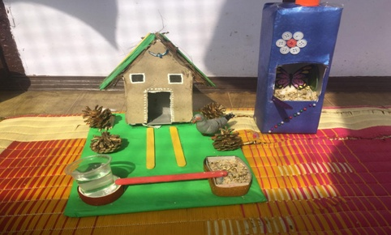

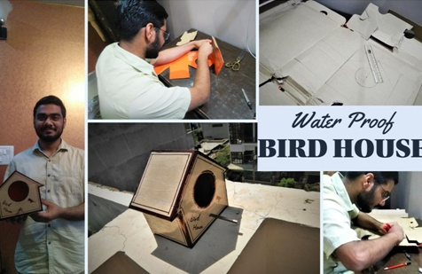

**Saatrangi 3080(20th -26th april 2020)**

Rotaract Club of Waknaghat in collaboration with Rotaract Club of DAV, celebrated a whole week as ‘Library week’, where each day a different task was allocated. Like, Role-play, Interactive session,Picture description, Book review, Quiz, etc. An overwhelming participation was seen by the club-members in this event. Altogether, it was an intriguing as well as a very engrossing span of events.

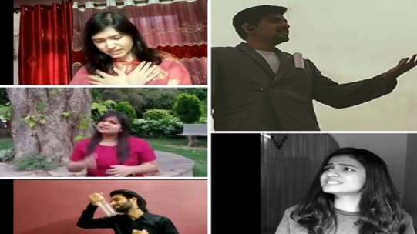

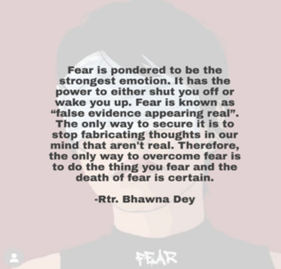

**Feed the Birds(20th April to 27 April 2020)**

Rotaract club of Karachi initiated the event, where all of us, could collectively do our bit for animals and birds by either making a shelter for birds or by feeding them by putting a box full of water and seeds outside our homes.

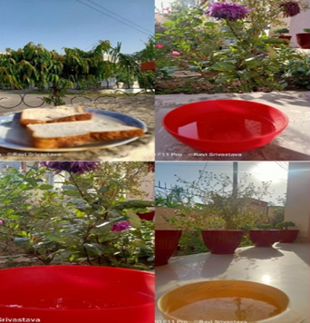 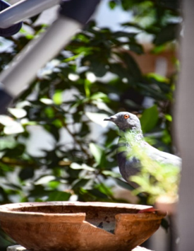

**TALKING BOOKS(27th April, 2020- 6th May, 2020)**

Many people wish to gain knowledge in books but are not able to do so because it demands patience and persistence to read them. Audio books on the other hand bridges the gap and lets them be more imaginative and creative without actually reading them but listening to them. They are also considered to be a highly preferable means to provide education to visually challenged people unlike Braille books that can go up to several volumes per book. Rotaract Club of Waknaghat explored an innovative way of contributing its bit to society without stepping out of the comfort of their homes during the lockdown. We took an entrancing initiative of recording course books to convert them to audiobooks for blind students. This, one week long project, grabbed the interest of many and helped in establishing a strong foundation for important skills.

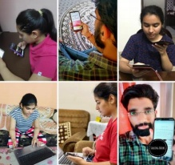 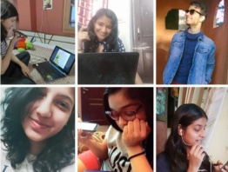

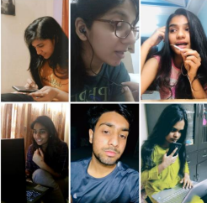

**HEROES IN SCRUBS(12th May 2020-18th May 2020)**

Wearing white coat like an armor, Using stethoscope like a sword, fighting back like a warrior. Doctors and Nurses, the real soldiers fighting Coronavirus in the combat zone. On the occasion of International Nurses Day, Rotaract Club of Waknaghat celebrated the whole week i.e. 12th May 2020 to 18th May in honor of the brave hearts who are serving us on the front-line and present them with a token of gratitude. This was done by making handmade masks or a video of rendering appreciation to all the people who are working so hard even during such a difficult time. We successfully got 60 entries and collaboration with 8 clubs from six districts!

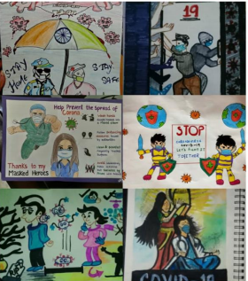 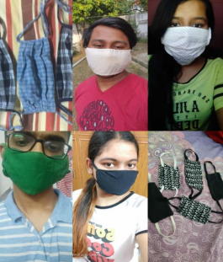

**GUFTGU SERIES(18-May-2020)**

‘Positive people, positive communication, positive interactions, positive work, and team cultures produce results.’ Rotaract Club of Waknaghat proudly launched “GUFTGU SERIES” amidst the lockdown to provide an enlightening platform for the members for proper guidance and direction towards the right path in life. This harmonious series was inaugurated by a marvelous, warm-hearted personality, Rtr. Arunima Sharma, Founder and the first president of Rotaract Club Of Waknaghat. ‘Guftgu Series’, is an ongoing event, the club is looking forward to connecting with several dynamic personalities and making the most out of this lockdown phase.

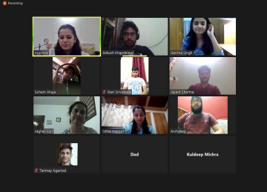

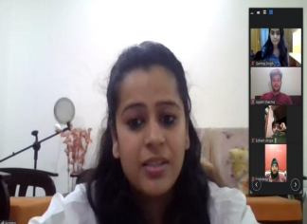

**DASTA-E-KHEL(12th May 2020)**

Rotaract Club of Waknaghat in collaboration with Rotaract Club Dombivili Suncity organized a fun games night. A number of interesting games were played by both the clubs like, Scavenger Hunt, Bollywood Trivia, Pictionary, Guess the Word, etc. Participants were enthralled by the wide set of titillating questions. Altogether, it turned out to be an amazing, recreational activity for everyone.

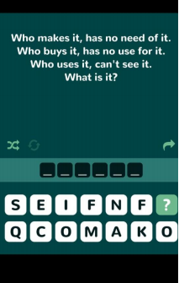 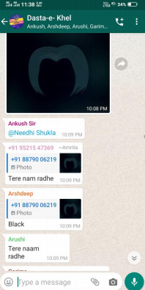

**GAME MARATHONS (Guess the song: May 20, 2020 & Netflix Quiz: May 25, 2020)**

Two sets of games were played under this project, Guess the song and Netflix quiz. Guess the song: •A picture with English lyrics of a song was uploaded. •Participants had to guess which Hindi Song it was. •Maximum Limit to guess was 3 mins. Netflix Quiz: •A picture with a question related to any Netflix show was uploaded. •Participants had to tell the correct answer. •Maximum Limit to answer was 3 mins.

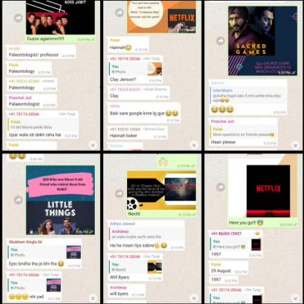 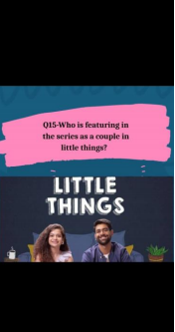

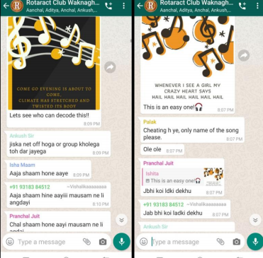

**Logo Design Competition (14th June 2020)**  
  
Stepping into a brand-new year and hailing new beginnings, Rotaract club of Waknaghat organized a logo designing competition to release a new logo for the club.

This gave a shot to fellow workmates to engage and show their creativity.

Many creative minds worked and gave their logos, among them top 7 were selected and then club members were asked to vote for their favorite one.  
  
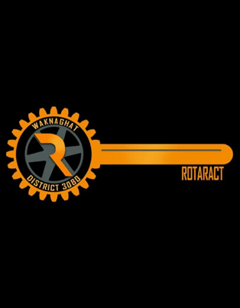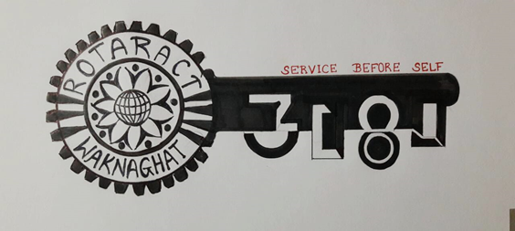

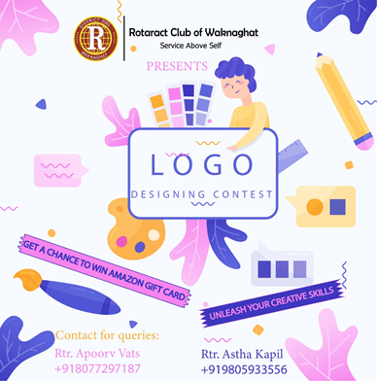

**RUBAB(1st July-7th July 2020)**

"If you are born with the ability to change someone's perspective or emotions, never waste that gift." In today's unprecented times, it's really difficult for a lot of people to keep up with the changing scenarios. The adversity is such that it's affecting a particular section of people more than the others. To contribute our bid towards change, Rotaract Club of Waknaghat took the initiative to help underprivileged section of society by taking small yet generous measures.

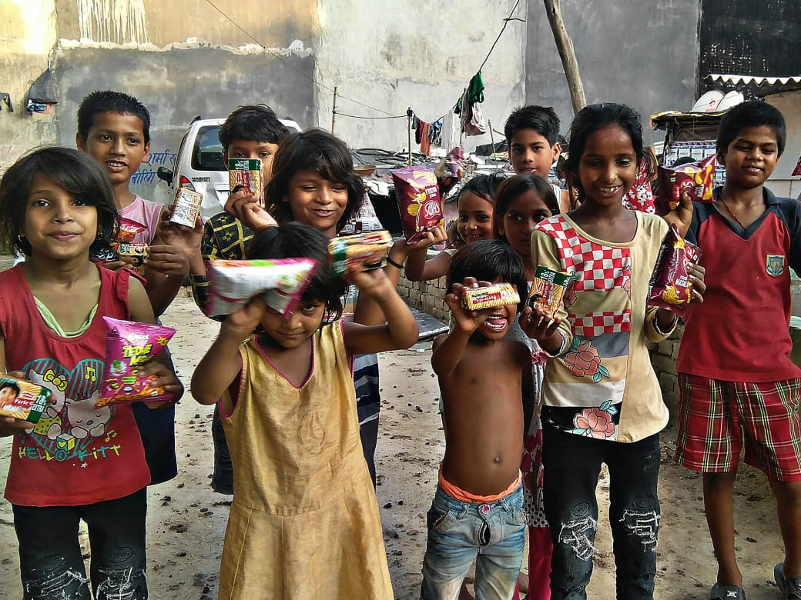 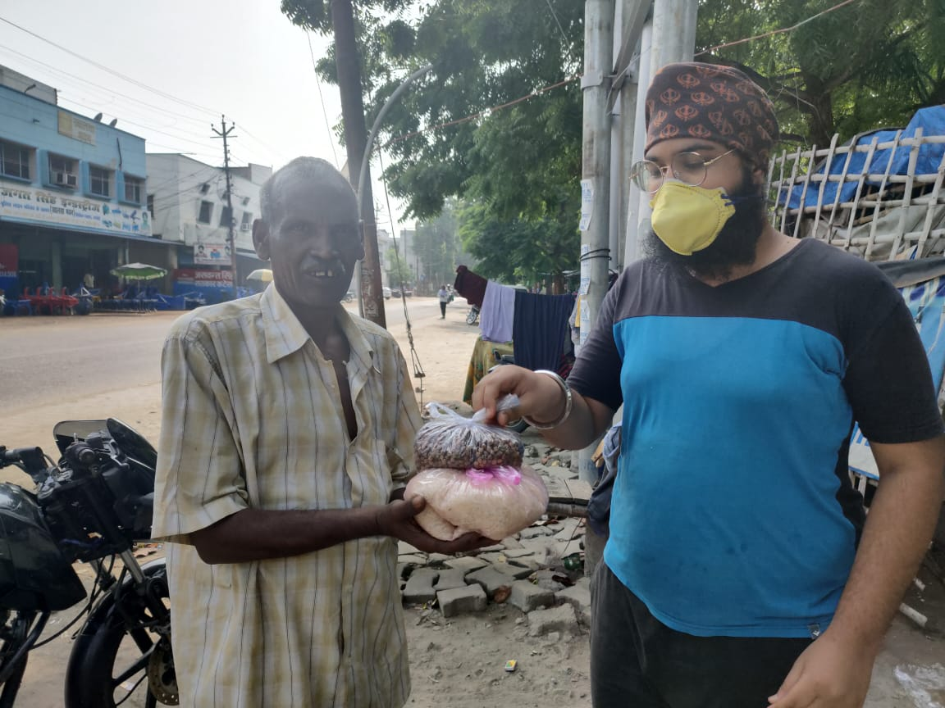

**Joint-Zonal event(8th July 2020)**

14.5% of the population is undernourished in India.

RI District 3080's Zone 1 took the responsibility to spread awareness regarding food scarcity and ways to avoid wastage of food. RAC Shimla Midtown launched an online (social media awareness) campaign. All the clubs were requested to post the posters along with the given caption to our clubs and personal social media accounts (instagram/facebook/whatsapp statutes) to spread awareness.

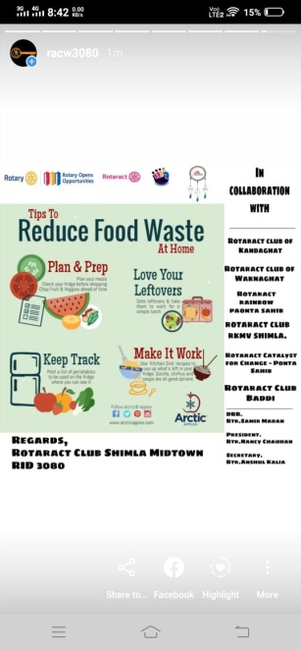 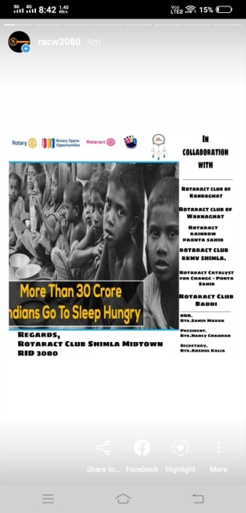 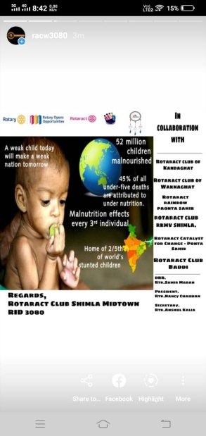

**POP QUIZ(August 2, 2020)**

• A picture with a question related to any cartoon show was uploaded.

• Participants had to tell the correct answer.

• Maximum Limit to answer was 3 mins, whoever gives the correct answer first, wins!

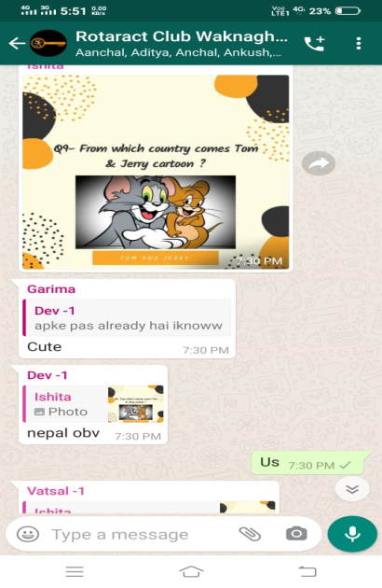 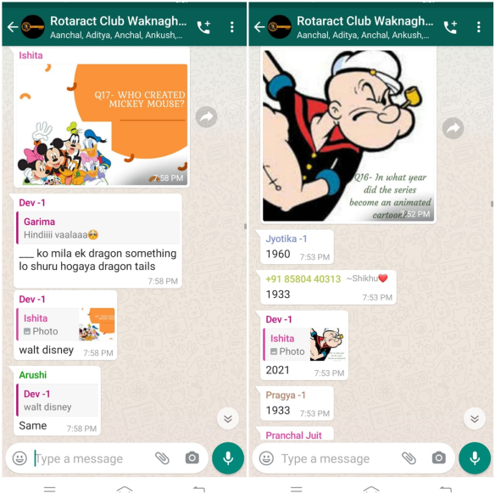

**Pour your heart out (8th Aug 2020)**

Rotaract club of Waknaghat organized "Pour your heart out", many people took part in the webinar to learn some expert advice on mental health care from our guest speaker, Namrata Jain. Many attendees sent in their questions and key challenges when it comes to dealing with daily life problems and Mental Health Care, which Namrata addressed during this session. She focused on many areas like Difference between a Psychologist and a Psychiatrist, difference between Anxiety and Worry, how to deal with negative thoughts and seeking Medical Help**.**

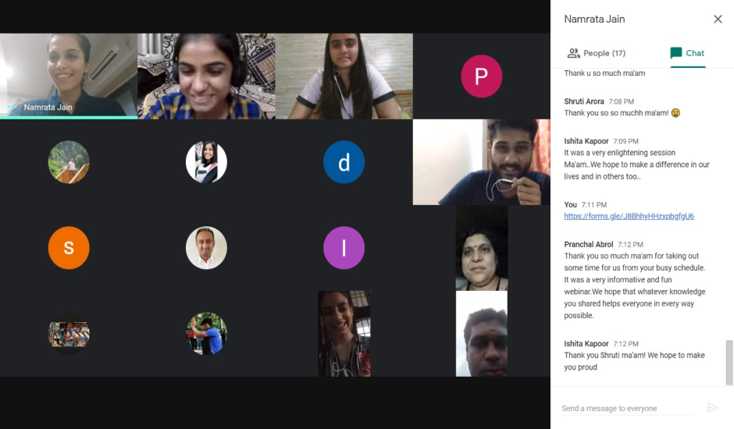

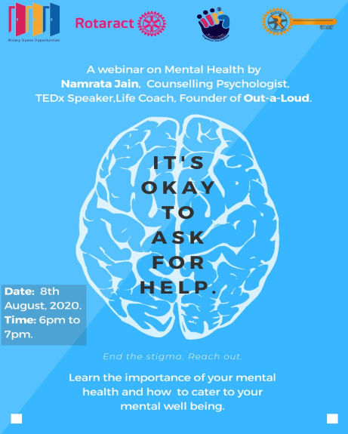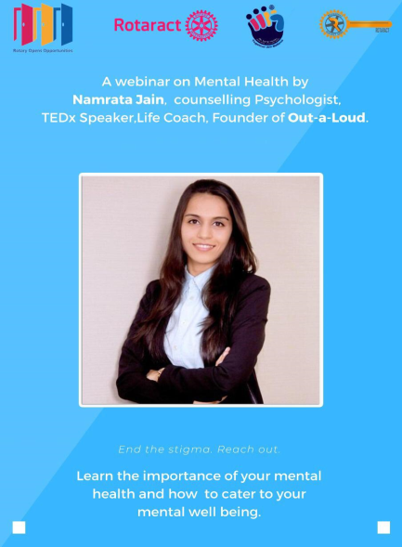

**Shradhanjali(15 August,2020)**

Rotaract club of Waknaghat organised an event on 74th Independence Day of India named "श्रद्धांजलि". The motto of the event was to pay homage to the real life heroes of our country. One was required to light a candle /diya in the rememberance of the brave martyrs. People from all across India participated in the event showing much gusto. Patriotism filled the air as we received more than 120 participation from different parts of India.

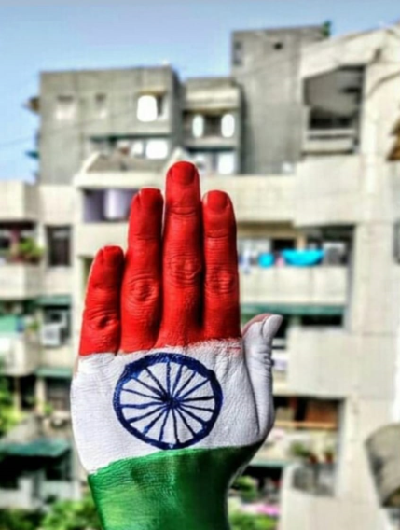 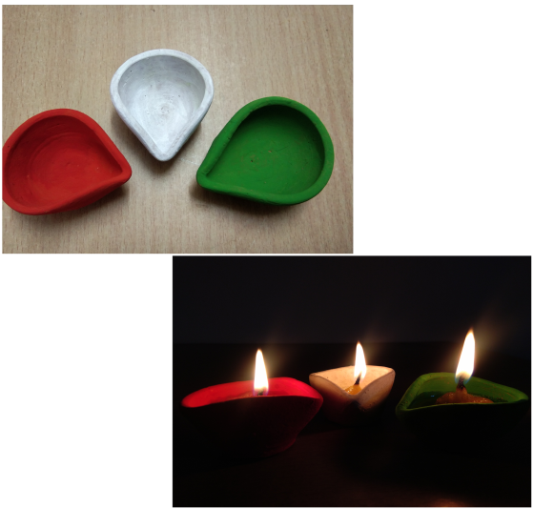

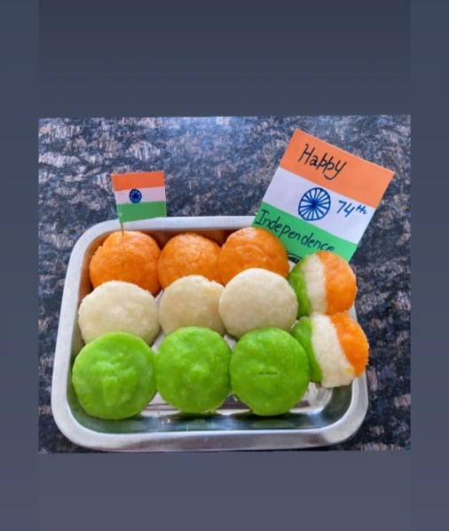

**Let's Up Skill (25th Aug 2020)**Rotaract Club of Waknaghat hosted Virtual sessions on Android App Development and Graphic Designing were conducted under this event, which proved out to be immensely informative and helped students get an edge on the two subjects. The fun way of teaching and learning experience was definitely the key- highlight of the event.

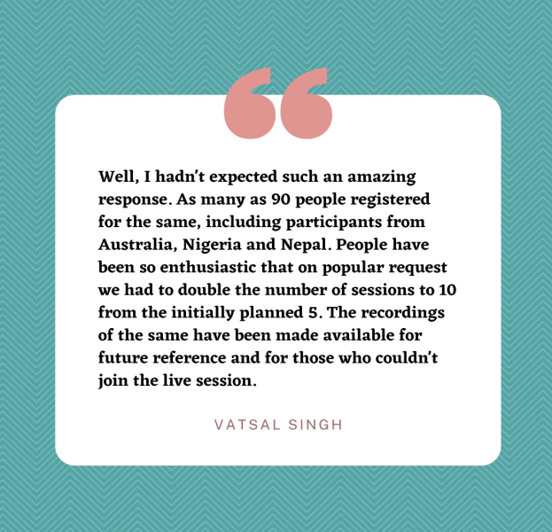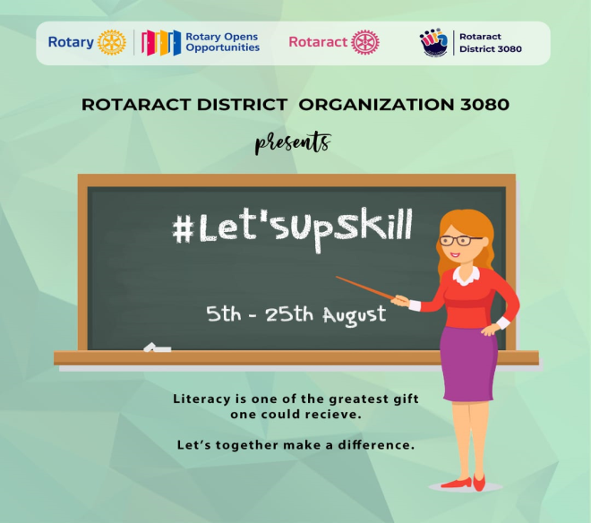

**Tree Plantation(28th August, 2020)**

Rotaractors participated in tree plantation drive with much gusto and enthusiasm , they selected the empty places around the roadsides to plant saplings in a well-organised way. In order to restore the eco-balance of the afforestation, drive was taken with all seriousness. The participants were highly enthusiastic to make it a big success.

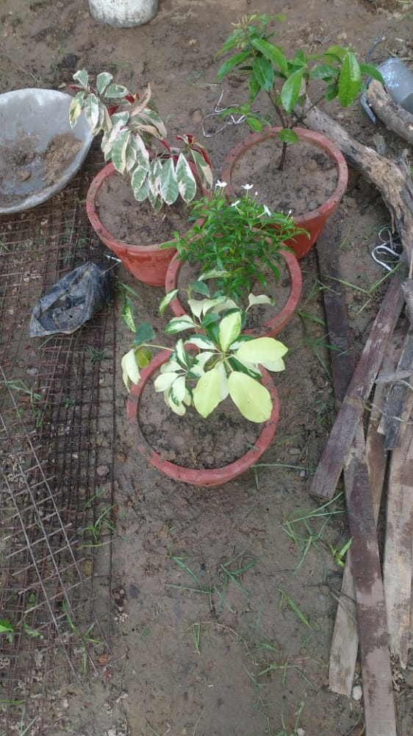 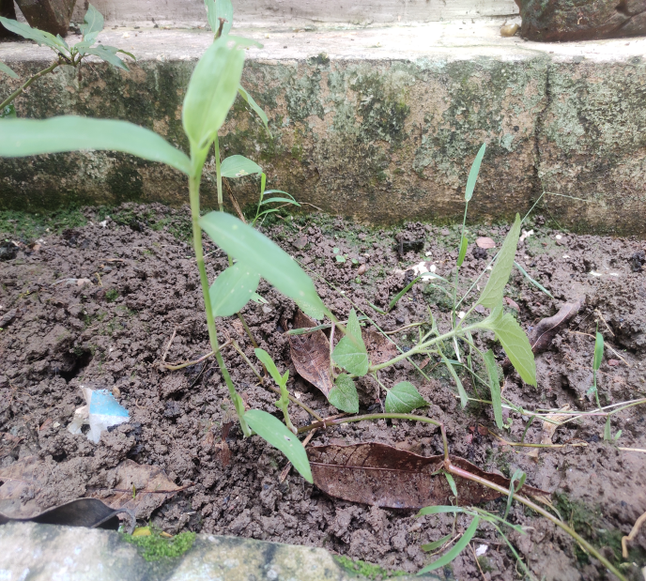

**Teachers day Tribute (5th Sept 2020)**Rotaract club of Waknaghat celebrated teacher’s day online this year. A virtual programmed had been arranged by the Rotaractors for their teachers. It is a new experience for the Rotaractors, but they all send their love and affection in form of a tribute video to teachers. The video was played for the teachers in the collage as well posted on the Instagram page of the club.  
  
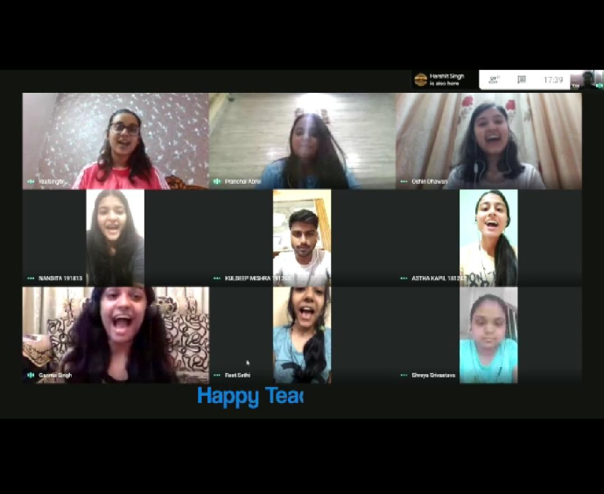 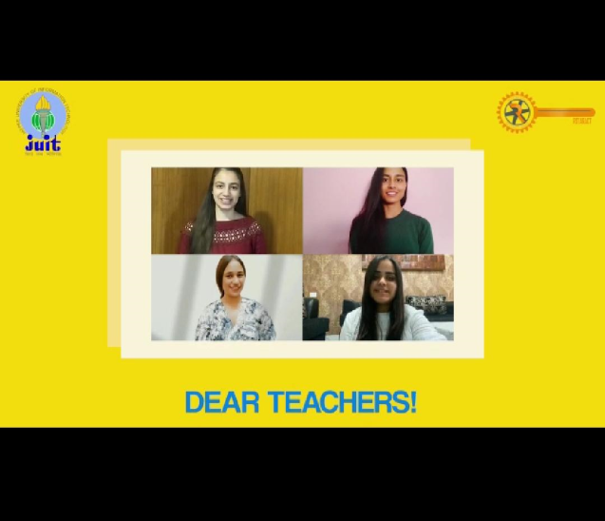

**Aagman(5th september,2020)**

Rotaract Club of Waknaghat organized an orientation for the freshers of 2020. The event started at 6 p.m. by playing an ice-breaking game.Then the formal meeting began by introducing our club and our mission for the year 2020-2021. Then we showed a glimpse of our last tenure's projects like blood donation camp, be someone's Santa, Har Ghar Roshan, RTP, Annapurna, ICYE, Rachna, etc. This was followed by traversing our club's avenues. After that, our President, Secretary, Vice President, Joint Secretary, and the entire board of directors introduced themselves to the first year students. Then our faculty co-ordinator Dr. Shruti Jain shared her experience with Rotaract club of Waknaghat and also highlighted the personality growth which she observed in every Rotaracter over the years.The meeting adjourned after the students asked their doubts regarding the club's working.

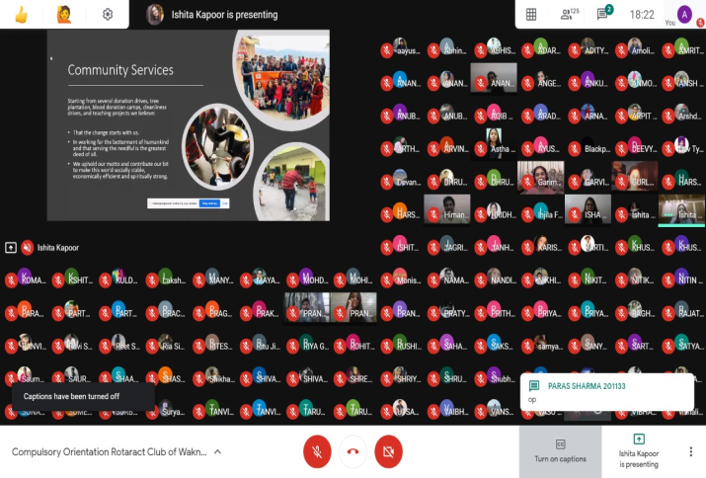 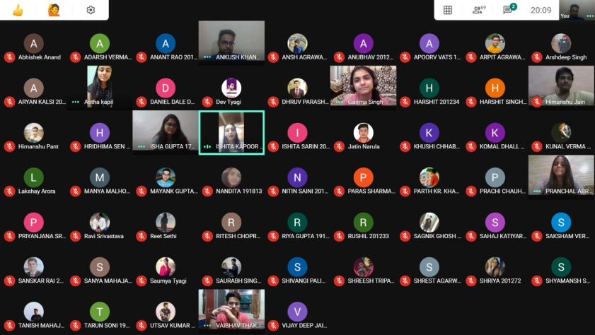

**Indoor Scavenger Hunt(12th Sept, 2020)**

Rotaract Club of Waknaghat organized an enticing Indoor Scavenger hunt. The hunt was conducted on the google meet platform. There was impressive participation showcased and all the participants played an instrumental role in making the whole quest an enormous success!

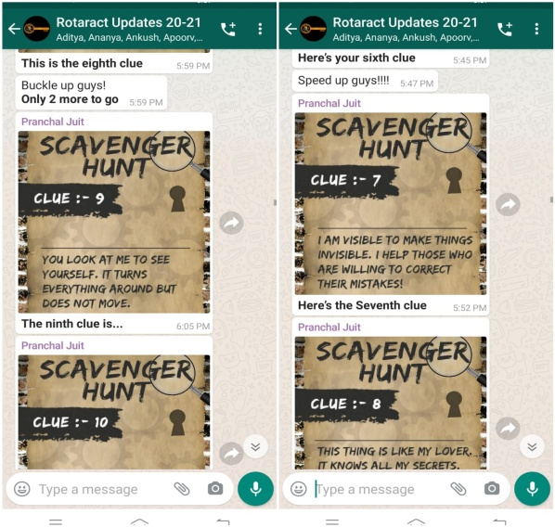 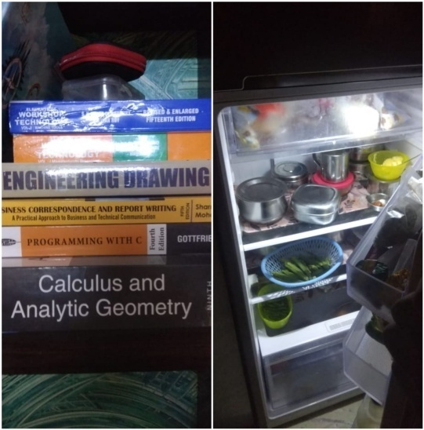

**Rachna(September 19th 2020)**

Rotaract Club of Waknaghat organized its flagship event ‘Rachna’. It was a lively and fun event which took place online for the first time. Target audience was the batch of first year students. There were several games included like chess, tambola, Call of duty mobile, scribble/pictionary, quiz, Picture Perception and Description.The games started around 3:00 PM. At the end of the fun filled evening, Mr. and Ms. Rachna were declared on the basis of their participation. The participants ended up completely ecstatic. Rachna 2020 ended with an informal interactive session around 8:00 PM.

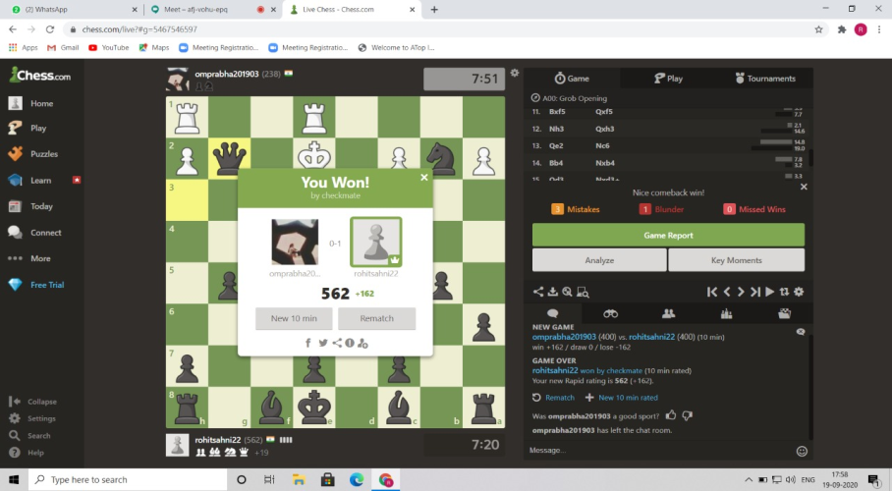 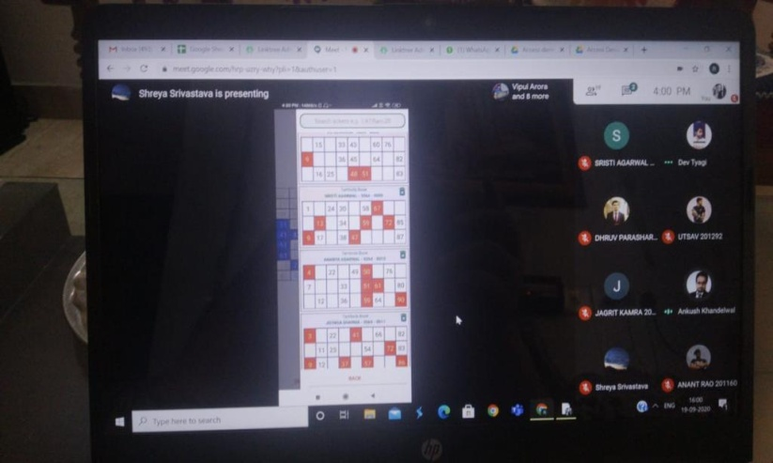 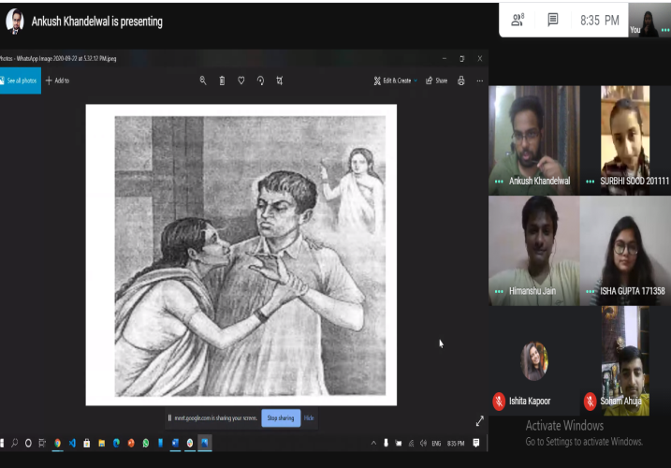

**HRIDAYAM (29th Nov 2020)**

A webinar ‘HRIDAYAM’ ‘My role during a chest pain’ was conducted which is celebrated as ‘World Heart Day’ by Rotaract Club of Dombivili Suncity along with the Rotaract Club of Waknaghat. The Speaker for the event was Dr Manpreet Arora MBBS, PGDHHM, Consultant General Physician, Motivational Speaker and Counselling Fortis Hospital Mulund. There was a complete presentation made by Dr Manpreet on Heart, its related issues and what one should to maintain a healthy heart and lifestyle.

There was also a proper question answer session kept for the participants which helped them clear their doubts and misconceptions.

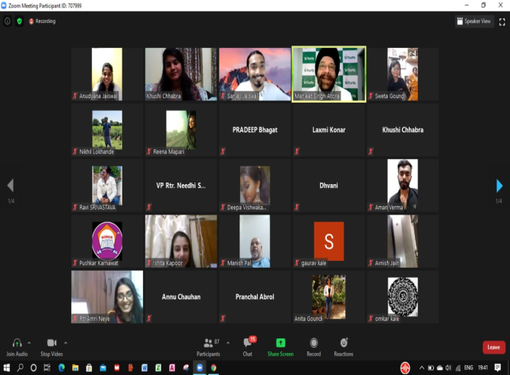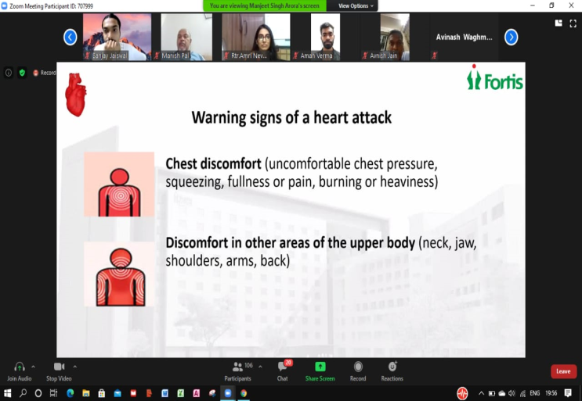

**Happy Tales (19th oct,2020 - 24th oct,2020)**

Rotaract Club of Waknaghat organised a week-long event "Happy Tales" full of charity, good spirits, and a lot of fun. The week embarked with the sanitary pad donation drive "SHE". This event was held in the slum areas of Shimla. More than 250 packets of sanitary pads were distributed among girls and women. We also informed everyone about the importance of pads and proper hygiene.

"Feed the Pawsome" was held on Day-2. Rotaractors from Chandigarh, Maharashtra, and Himachal Pradesh participated in this theme. 70+ innocent and voiceless animals were fed which brought a smile on the faces of everyone.

On day-3 the theme "Serve the birds" was planned for the people in the dry states of Rajasthan and Haryana. 40+ rotaractors kept out food and water for the feathered beings. Some also built beautiful birdhouses so that birds could eat, live, and lay eggs there.

"Adopt a plant" was held on Day-4 where 40+ Rotaractors pledged to adopt plants. Around 70 plants were planted on a single day in the states of Uttar Pradesh and Punjab. With the plantation of seeds and saplings, we wish to create a greener and cleaner environment.

"Re-book it" in the Delhi-NCR region was held on Day-5 of "Happy Tales". With the collaboration of 6 NGOs, we donated more than 500 books to the needy ones. With this highly successful book donation drive we did our bit of ensuring a better future. We hope that these books could impart education to those who could not buy them.

To end "Happy Tales" on a delightful note, we organized an online jamming session "Saturday Soiree".

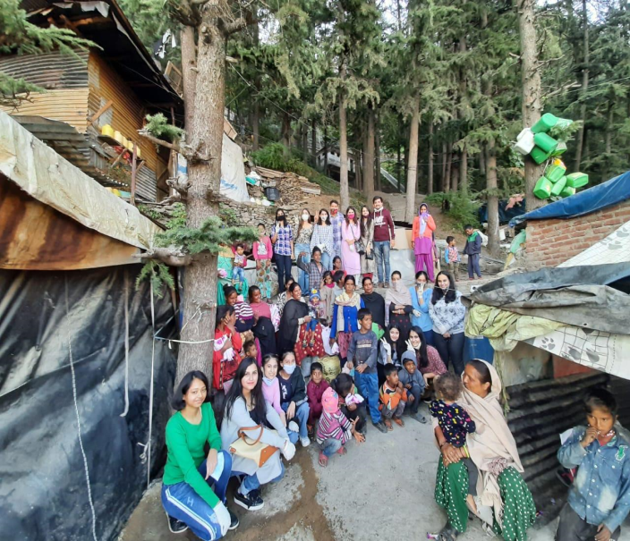 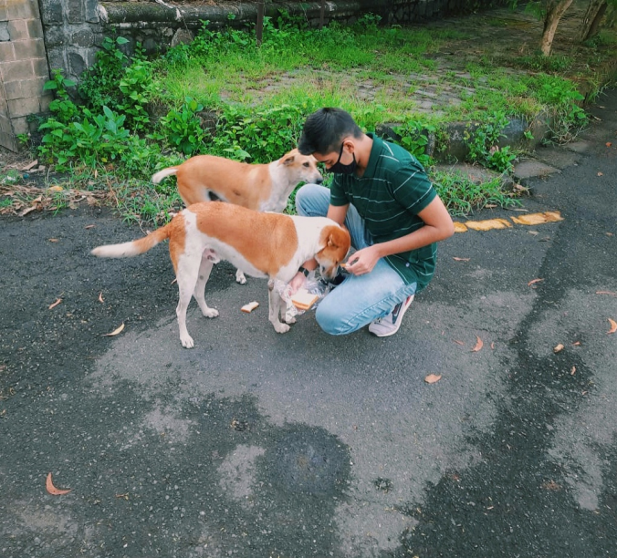 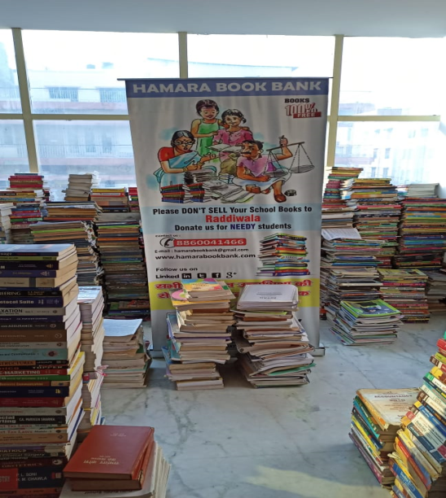

**Har Ghar Roshan (11th Nov,2020 - 16th Nov,2020)**

On the auspicious occasion of Diwali, Rotaract club of Waknaghat took an initiative of decorating every household with joy and happiness. The 6-day long event, "Har Ghar Roshan" was based on the motto "vocal for local" and the "art of giving". Participants were required to buy diyas, candles and other Diwali stuff from local(or street) vendors instead of buying from malls and big shops. They could also donate things they bought from the vendors to the underprivileged. A participation of more than 30 was received in this event. Rotaractors and non Rotaractors truly celebrated the art of giving in our hallmark event.

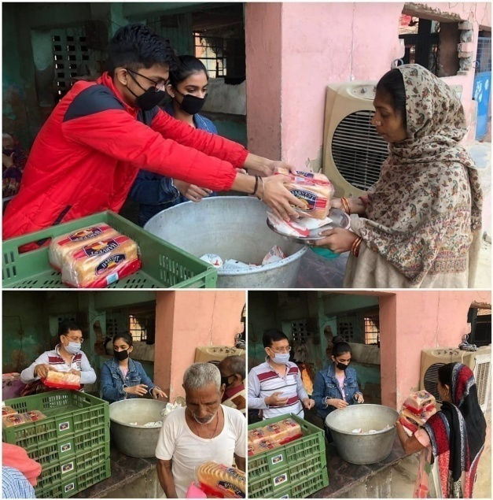 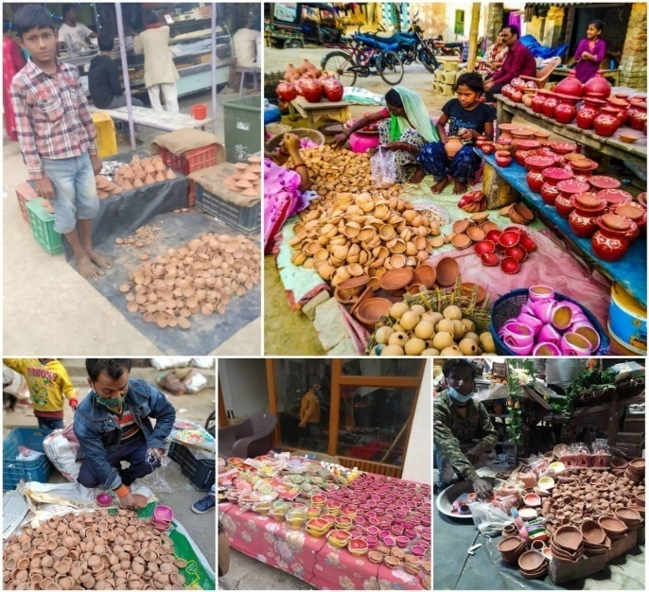 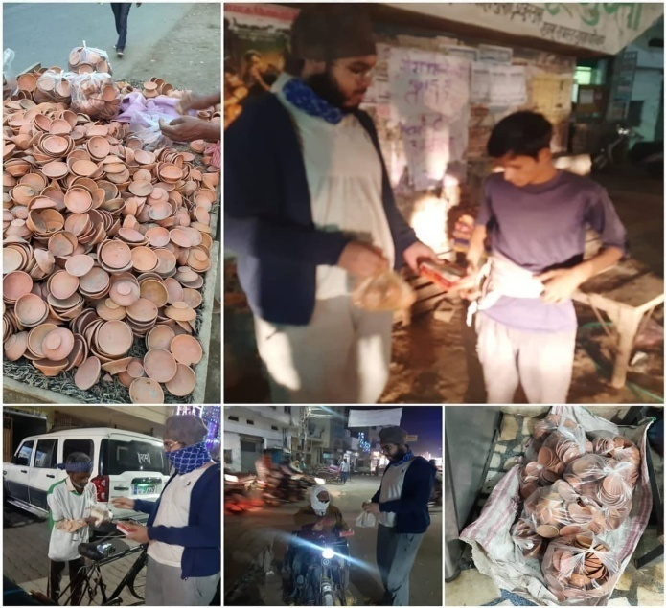

**Guess The Movie (23rd november,2020)**

Rotaract Club of Waknaghat organized an enticing Guess the movie by the poster challenge.The hunt was conducted on the main WhatsApp group. There was impressive participation showcased and all the participants played an instrumental role in making the whole game an enormous success!

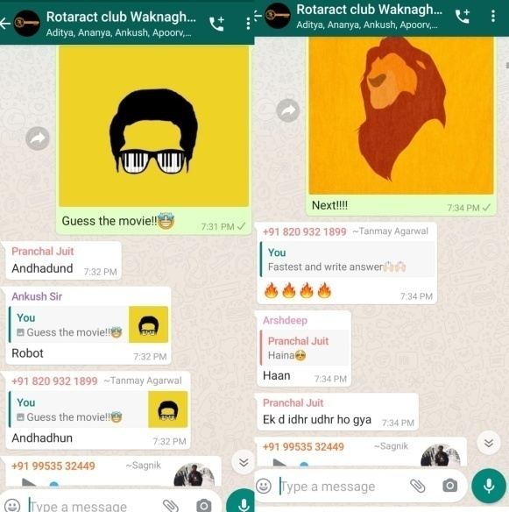 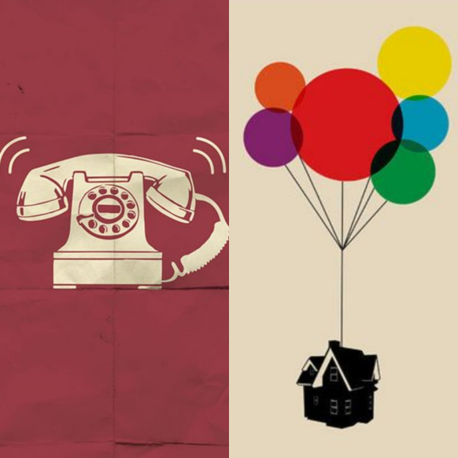

**Old age home Visit (20th Dec,2020)**

As we lose ourselves in the service of others, we discover our own lives and our happiness.

The members of Rotaract Club of Waknaghat organized an "Old age home Visit".Rotaractors visited Cheshire home, an old-age home in Lucknow, for community service. Donated some food items as per their requirements and they also interacted with all of them. Then one of the employees of the Cheshire home showed around the place, the organic vegetable and flower gardens. He showed their physiotherapy and the medical room that was equipped with exercise machines and other medical requirements.It was followed by a visit to their dormitories, where Rotaractors met an old lady and interacted with her.The team spent a little over two hours with them before saying goodbye. It was indeed a fulfilling experience for the members as they could bring smiles on their faces.

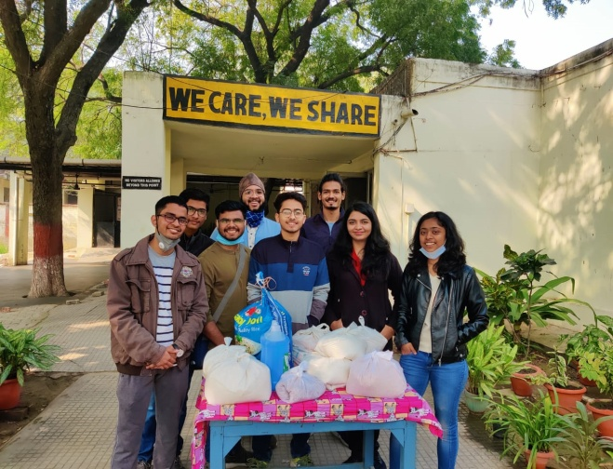 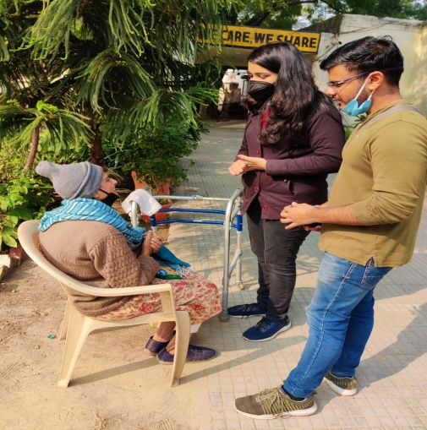 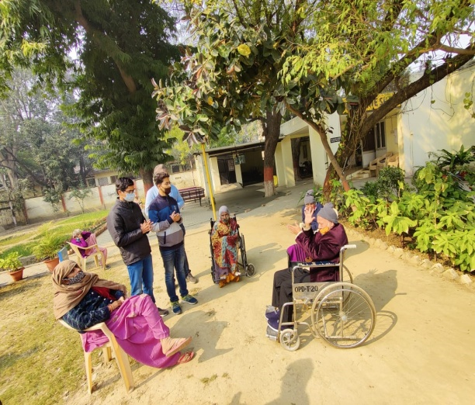

**State of the Arts (23rd Dec 2020)**

"Our hearts grow tender with childhood memories and love of kindred, and we are better throughout the year for having, in

spirit, become a child again at Christmas time." - Laura Ingalls Wilder

In the same spirit Rotaract Club of Waknaghat organized “State of the Arts” an online Poster making, and Painting competition themed around Christmas. The event saw good participation not only from seasoned Rotaractors but the rookies as well who have joined us just a couple of months back. Among the 24 entries that were received, we were dumbfounded by the creativity and skill of the participants, and the warmth of the festivity and holiday season could be felt across the board.

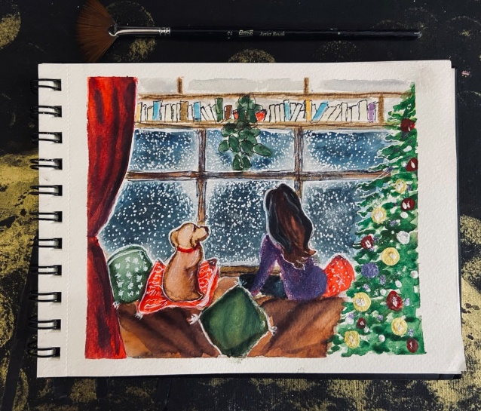

**Kindness Quest (28th December,2020)**

An event which was organised virtually for the meet and greet purpose. It was an informal and the only intent of this was to make everyone open up about themselves and talk about their wholesome experiences which they had this year in 2020. We had some exciting and brainstorming games that everyone seemed to enjoy.

Rotaractors of the club expressed their gratitude in a very nice manner and the event ended on a very positive note.

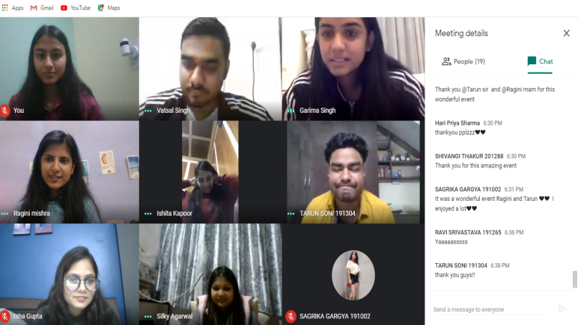

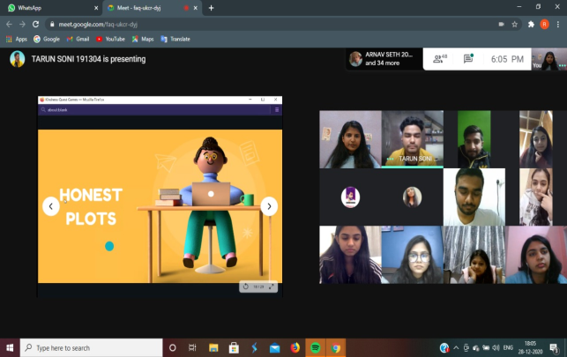

**Installation (30th Dec,2020)**

“Every great dream begins, with a dreamer, always remember, you have within you the strength, the patience, and the passion to reach for the stars to change the world.”

The offline Installation Ceremony was scheduled on 30th of December, 2020, at Rotary Town Hall Shimla .This is one of our most important and prestigious events, wherein we have badge pinning ceremony of board of directors for the current tenure. The event was graced by the presence of a lot of Rotaractors, offline. It was also live streamed for all the Rotaractors who couldn’t attend the event, physically.

